Jonathan Yang

Assignment 2

Birthday Class

**Test Case 1**

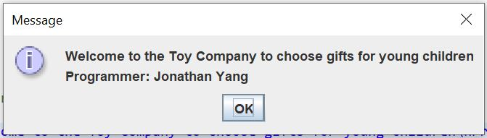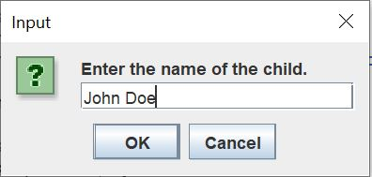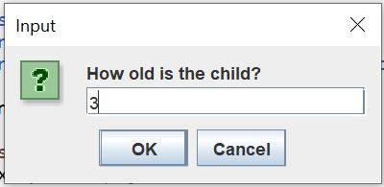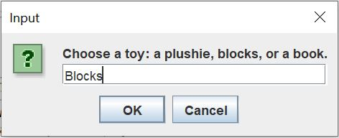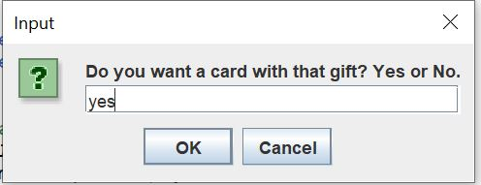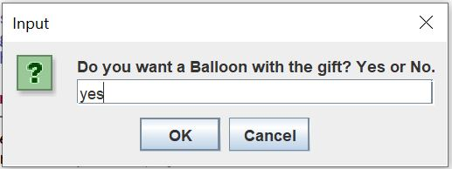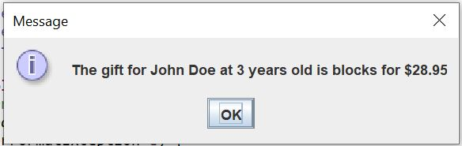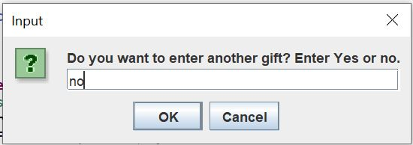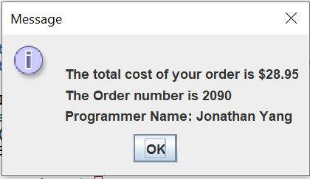

|  |  |  |  |  |  |
| --- | --- | --- | --- | --- | --- |
| Test Case # | Input | Actual Input | Expected Output | Actual Output | Did the test pass? |
| 1 | Name:  John Doe  Age:  3  Toy:  Blocks  Cards:  Yes  Balloon:  Yes | Name:  John Doe  Age:  3  Toy:  Blocks  Cards:  Yes  Balloon:  Yes | Age Ok:  Yes  Cost:  28.95 | Age Ok:  Yes  Cost:  28.95 | Yes |